**DAILY ONLINE ACTIVITIES SUMMARY**

|  |  |  |  |  |  |  |  |  |
| --- | --- | --- | --- | --- | --- | --- | --- | --- |
| **Date:** | **21/06/2020** | | | | | **Name:** | **NIKHIL KUMAR** | |
| **Sem & Sec** | **4thSEM. & ‘B’ SEC.** | | | | | **USN:** | **4AL19CS400** | |
| **Online Test Summary** | | | | | | | | |
| **Subject** | | **NIL** | | | | | | |
| **Max. Marks** | | **NIL** | | **Score** | | | **NIL** | |
| **Certification Course Summary** | | | | | | | | |
| **Course** | **Solid fundamental HTML, CSS, JavaScript Course** | | | | | | | |
| **Certificate Provider** | | | **BitDegree** | | **Duration** | | | **5hr** |
| **Coding Challenges** | | | | | | | | |
| **Problem Statement1 :** | | | | | | | | |
| **Status:---** | | | | | | | | |
| **Uploaded the report in Github** | | | | | **Yes** | | | |
| **If yes Repository name** | | | | | <https://github.com/Nikhil401/lockdown-certification-cource> | | | |
| **Uploaded the report in slack** | | | | | **Yes** | | | |

**Online test summary: Today I got coding question which I have mentioned in above table, Snapshot is given below…**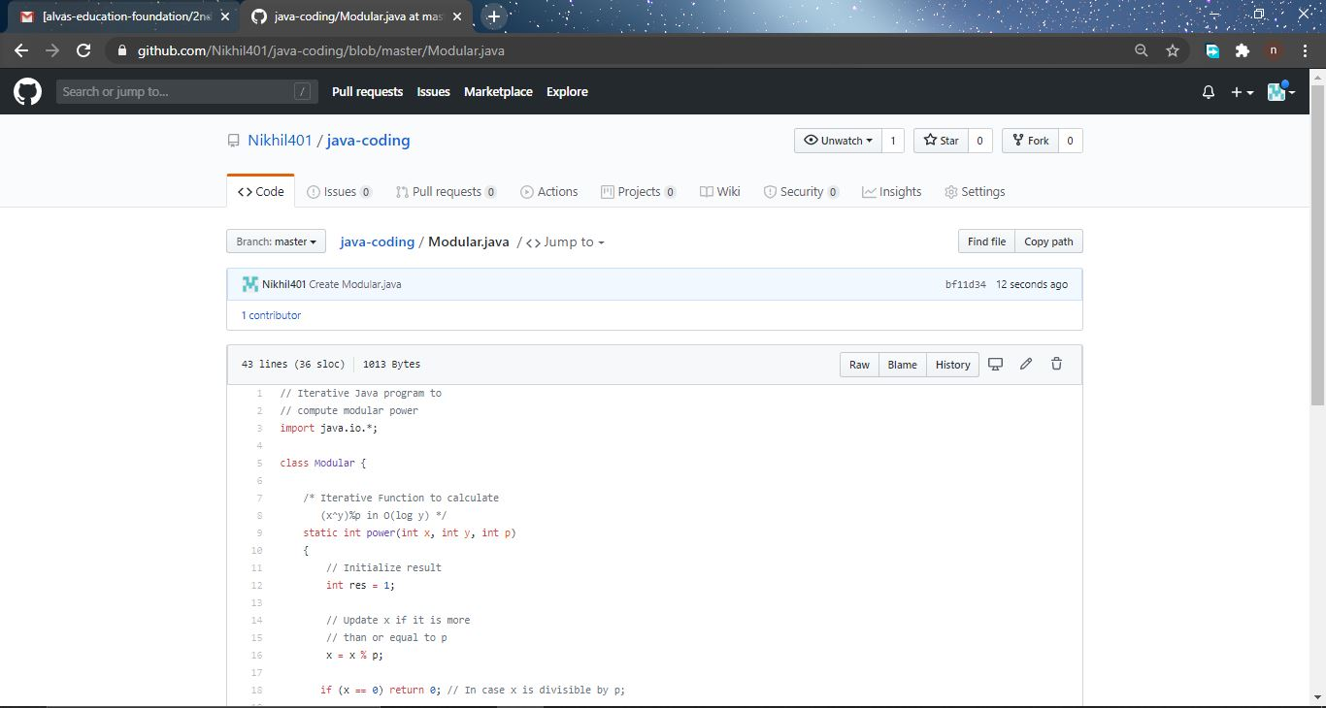

**Certification Course Summary: Today I have learnt about CMS, in browser web developer tools, online tools, an Integrated Development Environment“ Solid fundamental HTML, CSS, JavaScript Course” and the snapshot is given below:**

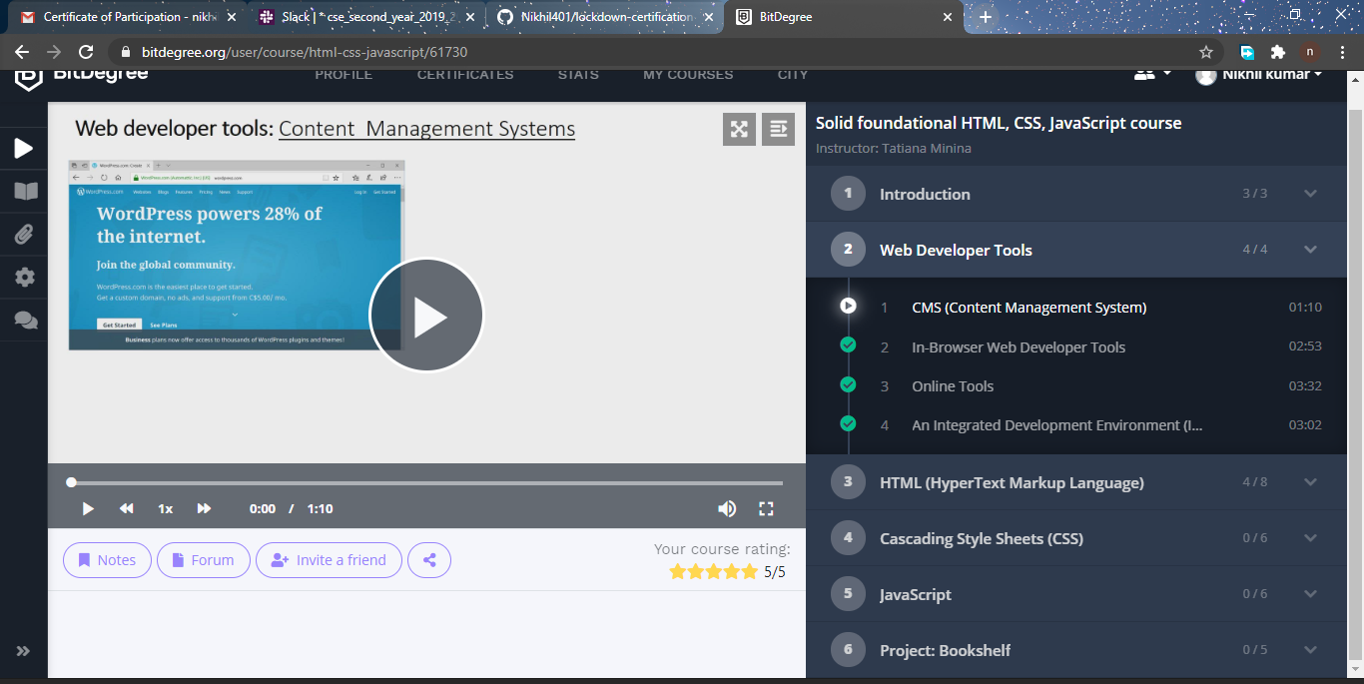**Thank you.**